LAB 01

Name: Muhammad Mohsin Nawaz

Class: BSAI-3B

Roll Number: SU92-BSAIM-F25-102

Submitted to: Sir Rasikh Ali

Outcome at a glance
Item | Result
Rule engine | Four named checks; all 5 test cases matched their expected label (5/5).
Comparison | The rules and the probability cut-off disagreed on 2 of 5 scenarios; both times the probability model was the more permissive one.
Key finding | A high score with missing documents is held by the rules but sent to review by the probability threshold.

1. Problem Framing and Objectives

1.1 Scenario
A university scholarship office wants an automatic first pass over applications so that its committee only spends time on promising files. This lab builds two competing screeners for that job and puts them side by side. The first applies written, inspectable rules. The second looks only at a single probability value, the kind of number a trained model might output. The question is not which one is "smarter" but what each one can and cannot be trusted to do, especially when an application is incomplete.

1.2 Objectives
- Place the main milestones of AI on a timeline and note what drove each shift.
- Build a symbolic rule engine with four explicit checks that explains every decision it makes.
- Compare that engine with a probability cut-off on controlled scenarios, including boundary and incomplete-file cases.
- Explain why passing a conversation test is not evidence of general intelligence, and propose a better benchmark.

2. Task 1: Milestones in the History of AI
The table lists five events that mark turning points in the field. For each one the point of interest is less the date itself and more what made it possible: a new idea, a funding shift, faster hardware or more data.
Table 1. Five milestones and why they matter
Year | Milestone | What happened and why it mattered | Reference
1950 | Imitation game proposed | Alan Turing replaced the vague question "can machines think?" with a behavioural test: could an interrogator tell a machine from a person using text alone? It gave the field a concrete, if debatable, target. | Turing, A. M. (1950). Computing machinery and intelligence. Mind, 59(236), 433-460.
1956 | Dartmouth workshop | A summer project proposed in 1955 by McCarthy, Minsky, Rochester and Shannon brought researchers together around the claim that learning and intelligence could be described precisely enough for a machine to simulate. The term "artificial intelligence" comes from this proposal. | McCarthy, J., Minsky, M. L., Rochester, N., & Shannon, C. E. (1955). A proposal for the Dartmouth summer research project on artificial intelligence.
1974-1980 | First AI winter | Early systems built on hand-written rules worked in narrow demos but did not scale to messy real problems on the computers of the day. A critical review commissioned in Britain and tighter budgets elsewhere cooled funding for several years. | Lighthill, J. (1973). Artificial Intelligence: A General Survey.
1997 | Deep Blue beats Kasparov | IBM's chess machine won a six-game match against the reigning world champion. Its strength came from search: custom chips examined on the order of 200 million positions every second, guided by hand-tuned evaluation. | Campbell, M., Hoane, A. J., & Hsu, F. (2002). Deep Blue. Artificial Intelligence, 134(1-2), 57-83.
2012 | AlexNet wins ImageNet | A deep convolutional network with roughly 60 million parameters, trained on two GPUs, cut the ImageNet top-5 error to about 15%, far ahead of the next entry. It showed that large models, big datasets and GPU compute together beat hand-built features. | Krizhevsky, A., Sutskever, I., & Hinton, G. E. (2012). ImageNet classification with deep convolutional neural networks. NeurIPS 25.

2.1 The compute trend behind the timeline
Reading the rows in order shows a pattern. Deep Blue was a symbolic-search system that depended on specialised hardware built for one game. AlexNet was a learned system that depended on general-purpose GPUs and a very large labelled dataset. The shift from writing the knowledge by hand to learning it from data is the same shift this lab explores at small scale: Section 3 uses rules written by a person, while Section 4 contrasts them with a score produced by statistical inference.

3. Task 2: Symbolic Rule Engine

3.1 Design
lab1_rules.py implements the screener as the conjunction of four named checks. An application receives the label Review only if every check passes; otherwise it receives Hold. Unlike a bare true/false, the engine also returns the list of checks that failed, so each outcome carries its own explanation.
Table 2. The four checks
# | Check name | Condition | Purpose
1 | documents_complete | documents_complete is True | Paperwork gate: nothing is assessed until the file is complete.
2 | score>=70 | score >= 70.0 | Minimum standardized test performance.
3 | gpa>=3.0 | prerequisite_gpa >= 3.0 | Minimum academic preparation (added for this lab).
4 | recommendation | valid_recommendation is True | Faculty endorsement is present and valid (added for this lab).

The rules are kept in a plain list of (name, predicate) pairs, so adding, removing or reordering a rule does not touch the decision logic. Figure 1 shows this part of the code.
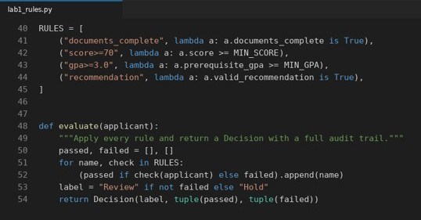
Figure 1.

3.2 Test cases and results
Five cases were written, each aimed at one behaviour: a clean pass, a failure caused only by GPA, a failure caused only by the recommendation, an applicant sitting exactly on both thresholds, and an applicant whose only fault is missing documents. Expected labels were decided before running the code.
Table 3. Test cases (all values from the run)
Case | Inputs | Expected | Actual | What the case checks
C1 standard pass | Score 88.0, Docs True  GPA 3.6, Rec True | Review | Review | Baseline path where all four checks are satisfied.
C2 GPA failure | Score 94.0, Docs True  GPA 2.7, Rec True | Hold | Hold | A very high score cannot make up for a GPA below 3.0.
C3 no recommendation | Score 79.0, Docs True  GPA 3.3, Rec False | Hold | Hold | A strong profile is still blocked without a valid endorsement.
C4 exact boundary | Score 70.0, Docs True  GPA 3.0, Rec True | Review | Review | Thresholds are inclusive: values equal to the limit pass.
C5 documents missing | Score 81.0, Docs False  GPA 3.4, Rec True | Hold | Hold | The paperwork gate stops an otherwise good applicant.

All five cases matched (5/5). The terminal output is in Figures 2 and 3; note the audit line under each case, which names the failed check or confirms that all four were satisfied.
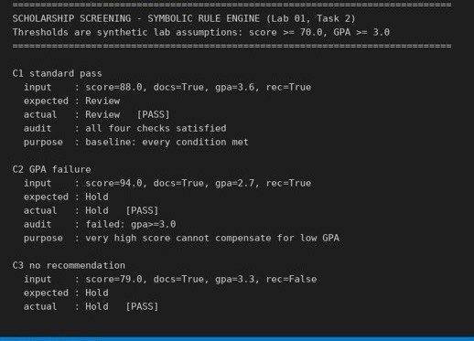
Figure 2.
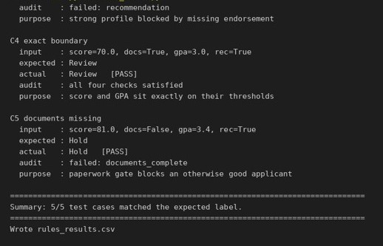
Figure 3.
Observations. Case C2 shows the defining property of a rule conjunction: strength on one criterion never compensates for failure on another. Case C4 confirms the comparison operators are inclusive at the boundary. Case C5 shows that the system can say exactly why an application was held, which is what a scholarship office would need when an applicant asks for a reason.

4. Symbolic Rules versus a Probability Threshold
lab1_compare.py runs five applicant scenarios through two screeners. The symbolic one is the engine from Section 3 (GPA and recommendation are held at passing values so only score and documents vary). The probabilistic one releases an application for review whenever a probability value is at least 0.70 and has no notion of documents at all. The probabilities are invented for the exercise.
Table 4. Scenario results
Scenario | Score | Docs | Prob | Symbolic | Probability model | Disagree
complete_high | 84 | True | 0.83 | Review | Review | False
complete_low | 66 | True | 0.72 | Hold | Review | True
incomplete_high | 93 | False | 0.90 | Hold | Review | True
boundary | 70 | True | 0.70 | Review | Review | False
weak_all_round | 55 | True | 0.41 | Hold | Hold | False

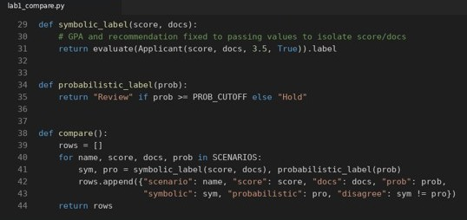
Figure 4.
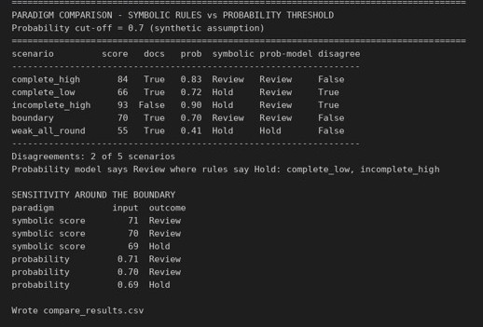
Figure 5.

4.1 Reading the disagreements
- A hidden cut-off (complete_low). The applicant has a score of 66, below the 70 requirement, so the rules hold the file. The probability model rates it 0.72 and releases it. That may or may not be a mistake, but the point is that the number has absorbed whatever else the model considered, and nothing in the output says which rule was traded away.
- Missing paperwork (incomplete_high). A score of 93 and a probability of 0.90 look excellent, yet the file is incomplete. The rules hold it because the document check fails. The probability threshold releases it because it never sees the document flag. A reviewer who trusts the high number would waste time on an application that cannot be awarded.
- Sharp edges in both systems (boundary). Dropping the score from 70 to 69 flips the symbolic result from Review to Hold, and dropping the probability from 0.70 to 0.69 flips the threshold result in the same way. Neither paradigm is gradual at its cut-off. The difference is that the rule engine can say which predicate failed, while the probability only offers a number below a line.

Table 5. How the two paradigms differ in this prototype
Aspect | Symbolic rules | Probability threshold
Explanation | Names the exact checks that failed. | Returns a single number with no reasons.
Missing information | Handled explicitly by a dedicated rule. | Silently ignored unless the model was trained on it.
Flexibility | Rigid: only covers situations someone wrote a rule for. | Flexible: can weigh many weak signals together.
Maintenance | Rules must be updated by hand when policy changes. | Needs fresh data and recalibration when the population changes.
Typical failure | Over-rejects unusual but valid applicants. | Over-accepts incomplete or out-of-pattern applicants.

5. Task 3: Conversation Tests and General Intelligence
The imitation game asks whether a judge can tell a machine from a person through text conversation. A system that does well is good at producing convincing language, but that is a narrower claim than possessing general intelligence or being dependable at a job.
Table 6. What a conversation test does and does not show
What it observes | What it cannot establish
Fluent grammar and natural phrasing | Those statements are factually correct
Plausible answers in context | That written constraints were actually followed
Ability to keep a conversation going | That the system knows when it does not know
Persuasive tone | That its reasoning can be audited or reproduced

5.1 A fluent but wrong answer
Suppose a chat assistant is asked about the incomplete_high applicant from Section 4 and replies: "This applicant scored 93 and is clearly outstanding, so I recommend awarding the scholarship immediately." The sentence is polished and confident, and it would probably pass as a human reply. It is also wrong, because the file is missing required documents and the rules say the application cannot proceed. The assistant has matched the pattern "high score means award" and has not applied the actual requirement.

5.2 A task-performance benchmark
A better test checks behaviour against rules, not style. The proposed constraint-compliance benchmark gives an AI agent a written screening policy and a set of applicant files, then scores its decisions against a reference engine such as lab1_rules.py. The score would combine:
- Decision accuracy on ordinary files.
- Boundary accuracy on files that sit exactly on a threshold.
- Trap handling on files built to tempt the agent, such as a very high score with missing documents.
- Justification quality: whether the agent names the specific rule that decided the outcome.
- Abstention: whether it asks for a human check when the policy is ambiguous instead of guessing.

6. Reflection and Responsible AI Practice

What I learned
Rules and probabilities fail in different ways. A rule engine is predictable and can be audited line by line, but it only covers what its author thought of. A probability is flexible, but it can hide the fact that a basic requirement was never considered. Seeing the incomplete_high case side by side made that difference concrete.

How I would apply it
In a real screening system, I would not choose one paradigm. Strict, policy-driven conditions such as complete paperwork would sit in a rule layer that can reject or hold a file, and a statistical model would only rank the files that survive that gate. Every decision would be logged with the rules that were introduced.

What surprised me
I had expected the disagreements to come from unusual numbers. Instead the most serious one came from a very good number: the highest probability in the set (0.90) belonged to the file the rules rightly held. High confidence does not mean the right inputs were examined.

Responsible AI notes
- Keep a person in the loop: a Review label means "send to the committee", never "award".
- Document thresholds and who owns them. A GPA or score cut-off can disadvantage certain groups, so it needs periodic fairness review rather than being treated as neutral.
- Be honest about limits: the values here are synthetic, only five scenarios were tested, and the probabilities were not produced by a real model, so the results illustrate behavior and do not measure accuracy.

7. Files and How to Run
Both scripts use only the Python standard library, so no packages need to be installed. Run them from the folder that contains the files, rules first, because the comparison script imports the engine:
python lab1_rules.py
python lab1_compare.py

lab1_rules.py prints the test report and writes rules_results.csv. lab1_compare.py prints the scenario table and sensitivity check and writes compare_results.csv.

